1. Arduino UNO :-

The Arduino Uno operates as the top choice for microcontroller boards in electronics projects through its straightforward interface and multiple applications under a single platform.

The ATmega328P (an 8-bit AVR microcontroller operating at 16MHz) powers Arduino Uno to execute basic processing tasks for prototyping and education needs besides preserving power efficiency.

The board comprises 14 digital I/O pins together with PWM-enabled pins from 6 pins and 6 analog inputs with 10-bit resolution which creates a simple platform to connect devices .like sensors along with motors and displays serving both basic LED circuit applications and interactive robotic control schemes.

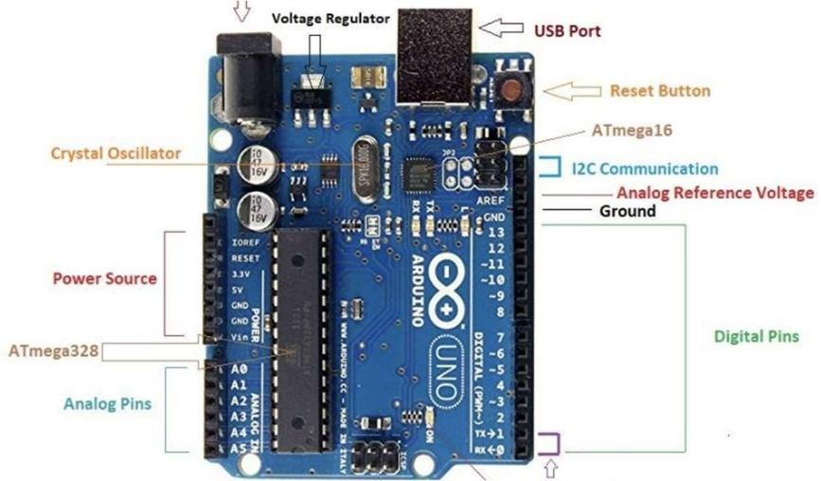

FIG 1 : Arduino UNO

Key advantages include:

The device supports USB programming that requires no external interface for programming.

* Flexible power options (USB or 7-12V DC)
* The device provides two power supply terminals that generate 5V or 3.3V output for peripheral appliances.
* The microcontroller features flash memory which stores user code and SRAM which handles variables with storage capacity of 32KB and 2KB respectively.
* Massive community support

1. LDR (Light Dependent Resistor) :-

LDR which is the stands for Light Dependent Resistor or Photoresistor. it is an passive electronic component which shows resistance adjustments because of changing light intensity. The high-resistance cadmium sulfide (CdS) semiconductor materials function as an LDR device by changing their resistance value between light and dark exposure environments.

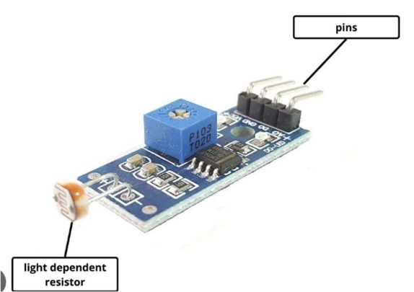

FIG 2 : LDR sensor

How Does an LDR Work:

* + Photoconductivity Principle: The resistance get reduced when the light photons hits the Semiconductor
  + Dark Resistance: In Dark ( when no light falling ) the resistance can be as high upto 1megaohm
  + Light Resistance : In the presence of light the resistance can go as low as few hundread ohms

1. GSM900a Module :-

As a 2G cellular module at 900 MHz GSM 900A serves for both SMS functions and voice calls together with basic GPRS data transfer. This mobile solution functions as an economical communication system particularly in 2G network areas that continue to operate. Among GSM 900A customers use The SimCom's SIM900A as a popular choice because of its miniature size along with UART interface and normal AT command support.

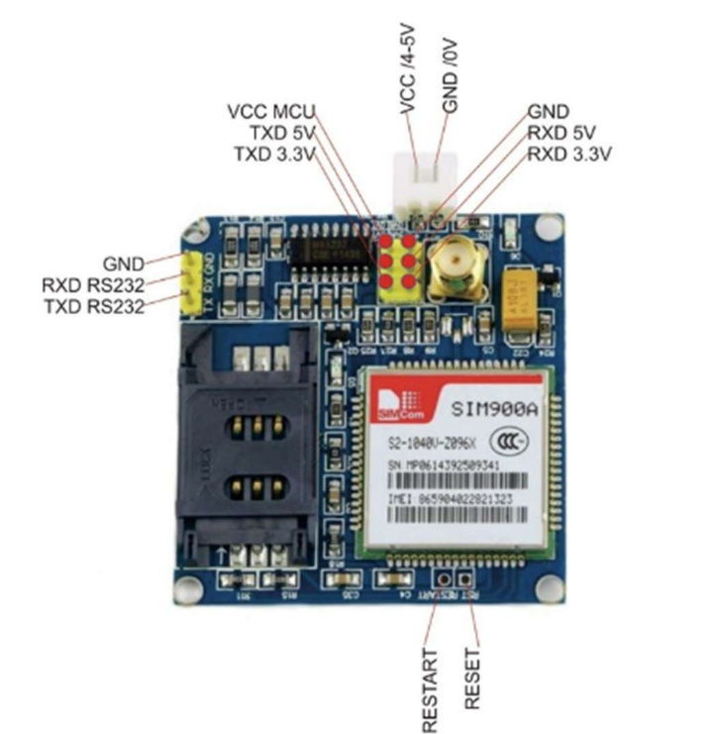

FIG 3 : GSM900a Module

Technical Specifications:

* + Frequency Band :- 900mhz primarly

* + GSM/GPRS Class 12 i.e it supports only 2G

* + Power Supply : 3.4V-4.5V but it is recommended to use 4V for stable operations

* + Peak current upto 2Amp during transmission

* + It is very sensitive small overload or fluctuation in power supply can easily damage the module